Document for Struts1.x and Struts 2.x
Prepared By : Garun Kumar Mishra
Date: 2017-03-30

Struts:
=>Struts 1 was the first release of MVC based framework by the apache Software foundation. In May 2000.
=> Apache Struts is used to create Java web appliation using Java Servlet API and Model-View-Controller(MVC) architecture.
=> Struts has a set of tag libraries and their associated classes.
=> Struts is an open source and uses java Servlets, Java Server Pages and Java Beans. It interacts with the database and business logic engine to customize a response.
=> In a normal web application, cleint is called to a server, the information submitted is handed to Java Servlet that interacts with database to produce the HTML response. The information can be submitted to JSP that combines java code with HTML. Both approach do not work when it comes to a large projects and hence we require Struts.
=>Apache Struts is an open-source web application framework for developing Java EE web applications. It uses and extends the Java Servlet API to encourage developers to adopt a model-view-controller (MVC) architecture. It was originally created by Craig McClanahan and donated to the Apache Foundation in May, 2000.
Struts Architecture:

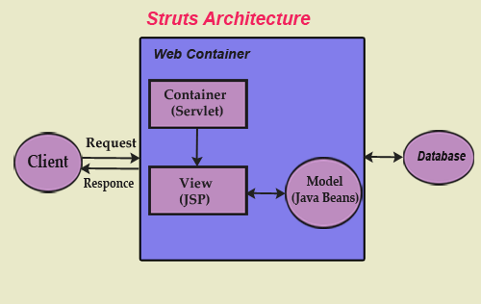

=> Struts framework has Request handler, Response Handler and a tag library.
=>Before Moving to More about Struts we must understand the MVC.

Model View Controller:
=>In MVC controller handle the user request instead of another JSP. The controller is implemented as Servlet.
=>Model 1 Architecture:
-> In the model 1, Browser directly access JSP pages. In Other words, user request handled directly by JSP pages.
->Consider a HTML pagewith a hiperlink to a JSP. When user click on hiperlink, the JSP is directly invoked. The Servlet container parse the JSP and executes the resulting java servlet.
->In addition, it contains the logic to connect the middle tier or directly to the database using JDBC to get additional dataneeded to display the page.
=> Disadvantage of Model 1:
-> Java Code(Business logic) is in JSP page so maintainanace is dificult.
->Application control is decentralized in model 1 architecture since the next page to be displayed is determind by the logic embedded in current page.
=>Model 2 Architecture:
In MVC controller handles the user request instead of another JSP. The controller is implemented as a Servlet. The following steps are executed when the user submits the request.
1. The Controller Servlet handles the user’s request.
2. The Controller Servlet then instantiates appropriate JavaBeans based on the request parameters.
3. The Controller Servlet then communicates with the middle tier or directly to the database to fetch the required data.
4.The Controller sets the resultant JavaBeans ( results from database) in one of the following contexts – request, session or application.
5. The controller then forward or redirect to different JSP show result data.

=>Advantage with MVC
Java code (business logic)is in business tier no business logic in JSP page so maintenance is easy. Separation of view (jsp) and model ( business logic)

Struts and Model View Controller:
=> Struts flow Model View Controller Architecture. Componenet is divided base on MVC:

A. Controller: The ActionServlet and collaborating classes are RequestProcessor, ActionForm, ActionMapping, Action and ActionForward in Controller category.
ActioSnServlet: The central component of struts controller is ActionServlet. It is a concrete class and extends the javax.servlet.HttpServlet. It perfroms two important things:
1. On Startup, It reads the Struts configuration file and load into memory in the init() methods.
2. In the doGet and doPost methods, it intercepts HTTP requestand handles it appropriately.
B. View: The View category contains utilities classes – veriety of custom tags(html, bean, logic) and JSP.
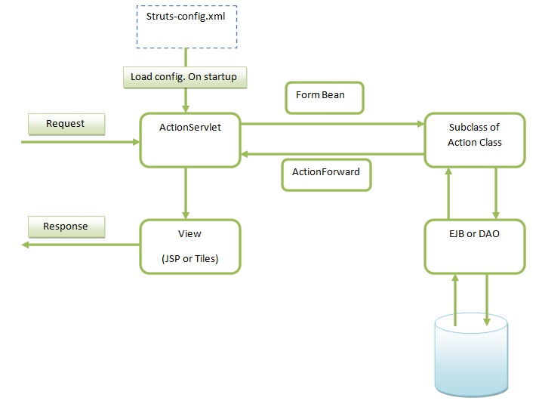
C. Model: Struts does not offer any component in Model category. Your action class contains business logic may be model.

Struts Flow:
=> Struts flow starts with ActionServlet then call to process() method of Request Processor.
Step 1. Load ActionServlet using load-on-startup and do the following tasks.
Any struts web application contain the ActionServlet configuration in web.xml file.
On load-on-startup the servlet container Instantiate the ActionServlet .
First Task by ActionServlet : The ActionServlet takes the Struts Config file name as an init-param.
At startup, in the init() method, the ActionServlet reads the Struts Config file and load into memory.
Second Task by ActionServlet : If the user types http://localhost:8080/app/submitForm.do in the browser URL bar, the URL will be intercepted and processed by the ActionServlet since the URL has a pattern *.do, with a suffix of "do". Because servlet-mapping is
<servlet-mapping>
<servlet-name>action</servlet-name>
<url-pattern>*.do</url-pattern>
</servlet-mapping>
Third Task by ActionServlet : Then ActionServlet delegates the request handling to another class called RequestProcessor by invoking its process() method.
<servlet>
<servlet-name>action</servlet-name>
<servlet-class>org.apache.struts.action.ActionServlet</servlet-class>
<init-param>
<param-name>config</param-name>
<param-value>/WEB-INF/struts-config.xml</param-value>
</init-param>
<load-on-startup>1</load-on-startup>
</servlet>
<servlet-mapping>
<servlet-name>action</servlet-name>
<url-pattern>*.do</url-pattern>
</servlet-mapping>
Step 2. ActionServlet calls process() method of RequestProcessor.
The RequestProcessor does the following in its process() method:
a) The RequestProcessor looks up the configuration file for the URL pattern /submitForm (if the URL is http://localhost:8080/app/submitForm.do). and and finds the XML block (ActionMapping).
ActionMapping from struts-config.xml
<action path="/submitForm"
type="com.techfaq.emp.EmpAction"
name="EmpForm"
scope="request"
validate="true"
input="EmpForm.jsp">
<forward name="success"
path="success.jsp"/>
<forward name="failure" path="failure.jsp" />
</action>
b) The RequestProcessor instantiates the EmpForm and puts it in appropriate scope – either session or request.
The RequestProcessor determines the appropriate scope by looking at the scope attribute in the same ActionMapping.
c) RequestProcessor iterates through the HTTP request parameters and populates the EmpForm.
d) the RequestProcessor checks for the validateattribute in the ActionMapping.
If the validate is set to true, the RequestProcessor invokes the validate() method on the EmpForm instance.
This is the method where you can put all the html form data validations.
If Validate fail the RequestProcessor looks for the input attribute and return to JSP page mentioned in input tag.
If Validate pass goto next step.
e) The RequestProcessor instantiates the Action class specified in the ActionMapping (EmpAction) and invokes the execute() method on the EmpAction instance.
signature of the execute method is
public ActionForward execute(ActionMapping mapping,
ActionForm form, HttpServletRequest request,
HttpServletResponse response) throws Exception
{
//your logic
return mapping.findForward("success");
}
f) In return mapping.findForward("success")
RequestProcessor looks for the success attribute and forward to JSP page mentioned in success tag. i.e success.jsp.
In return mapping.findForward("failure")
RequestProcessor looks for the failure attribute and forward to JSP page mentioned in failure tag. i.e. failure.jsp

Some Important Question-Answer related to struts :
Q1: What is Action Class? Explain with Example.
Ans: An action class in the Struts application extends Struts's 'org.apache.struts.action.Action' class. Action class acts as wrapper around the business logic and provides an interface to the application's Model Layer. An Action work as an adapter between content of incoming HTTP request and the business login corrospond to it. Then the struts controller (ActionServlet) select an appropriate Action and Request Process creates an instance of necessary and then finally calls execute method of Action class.
To use the Action, we need to subclass and overrite the execute() and your business logic will be in execute method. It return type of execute method is ActionForward which is used by struts framework to forward the request to JSP as per the value of returned ActionForward.
Developing our Action Class :
Our Action class (EmpAction.java) is simple class that only forwards the success.jsp.
Our Action class returns the ActionForward called "success", which is defined in the struts-config.xml file (action mapping is show later in this page).
Here is code of our Action Class
public class EmpAction extends Action
{
public ActionForward execute(
ActionMapping mapping,
ActionForm form,
HttpServletRequest request,
HttpServletResponse response) throws Exception{
return mapping.findForward("success");
}
}
mapping.findForward("success"); forward to JSP mentioned in struts_config.xml.

struts_config.xml configuration is :
<action path="/EmpAction" type="com.techfaq.EmpAction">
<forward name="success" path="/success.jsp"/>
</action>
mapping.findForward("success") method forward to success.jsp (mentioned in struts_config.xml);
Here is the signature of the execute() method Action Class.
public ActionForward execute(ActionMapping mapping,
ActionForm form,
javax.servlet.http.HttpServletRequest request,
javax.servlet.http.HttpServletResponse response)
throws java.lang.Exception
Where
mapping - The ActionMapping used to select this instance
form - The optional ActionForm bean for this request (if any)
request - The HTTP request we are processing
response - The HTTP response we are creating
Throws:
Action class throws java.lang.Exception - if the application business logic throws an exception
In the browser : http://localhost:8080/testApp/EmpAction.do
This will call to execute() method of EmpAction and after that based on mapping.findForward("success") forward to success.jsp.
Q2: How you can do Exception Handling in Struts?
Ans: There are two approach to Handle the Exception in Struts:
1. Declearative
2. Programatic
1. Declearative: Exception are defined in struts-config.xml file and If exception is occured then the control is automatically passed that to appropraite error page. The <exception> tag is used to define the exception in struts-config.xml file.
For Example : (( If RuntimeException in SaveEmpAaction class , control goes to exception.jsp)
<action path="/saveEmp" type="com.techfaq.SaveEmpAaction" input="/empform.jsp" >
<exception key="error.system" type="java.lang.RuntimeException" path="/exception.jsp" />
</action>
where the key defines the key present in MessageResource.properties file to describe the Exception occured. The Type is the class of exception occured. Path is the page where the control is to be followed in case exception occured. And finally the exception Handler wich will be called before parsing the control to the file specified path attribute.
2. Programmatic: In this approach the exceptions are caught using normal java language try/catch block and instead of showing the exception some meaningful message are displayed. In this approach the flow of control is also maintained by the programs. The main drawback of this approach is the developer has tio write the code for the flow of application.
Q3: How Iterate tag used with a Map?
Ans:
<logic:iterate id =”user” name=”user” property=”usermap” >
<tr><td>User id : <bean:write name=”user” property=”key” /></td>
<td>Password: <bean:write name=”user” property=”value” /> </td></tr>
</logic:iterate>
Q4: Can I have an Action class without From?
Ans: Yes, If your action doesnt need any data and it does not need to make any data available to view or controller component that it forward to, then it doesnt not need a form. A good example of an Action with no ActionForm is LogOffAction in struts example application.
<action path="/logoff" type="org.apache.struts.webapp.example.LogoffAction">
<forward name="success" path="/index.jsp"/>
</action>
This action needs no data other than the user's session, which it can get from the request, and it doesnt not need to prepare any view element for display, So it doen't need a form.
Q5:What are the validators? What are basic validators provided by Struts frameworks? What are the benifits of validator?
Ans: Validator is a Java Class that, when called by validator frameworks to executes a validation rule. The framework knows how to incvoke a validator class based on the method signature, as defined in configuration file.
i) byte, short, integer, long, float, double
ii) creditCard – It checks if the field is valid credit card number.
iii) date – checks if field is valid date.
iv) email – checks that field is valid email address.
v) mask – Succeed if the field matches the corrosponding regular expression.
vi) maxLength and minLength
vii) range – check if the value is within a minimum and max range.
Viii) required – check if field is not null and length of the field is greater than zero, not inckuding whitespace.
Benifit of validators:
=>A Single definition of validation rule for an application.
=>validation rules are loosle coupled to the application.
=>Server side and client side rules can be defined in one location.
=>Configuration of new rule and/or changes to existing rule are made simpler.
=>Support Internationalization.
=>Support Regular expression.
=>Validators can be used for both Web based and standard Java application.
=>Promotes a declearative approach rather than a programmatic one.

Struts 2.x

=>Struts 2 is an open source web based framework based on Model View Controllerdesign pattern. The latest stable version of struts is struts 2. This project is from apache and is combination of Web Framework 1 and struts 2. It is highley extensible and flexible framwork for web application development.
=> The jey feature of struts 2 are Interceptor, Result type, easy integeration with other framework through plugins, Implementation of Inversion of Control (IoC), Internationalization, and Tile integeration etc.
=> It is web application framework with tools, and API for creating web application.
=> It implements Front Controller approach like – Struts 1 and String Web MVC Framework.
=> The Struts 2 action classes are core concept and represents Model class itself which contains business logic for processing on the data. Action classes act as controller in the MVC pattern.
=> The Struts 2 framework provides powerful tag libraries to create view pages. It can be use to create view pages in very easy.
- Control Tags
- Data Tags
- Form Tags
- non-Form Tags
=> After executing the Action class, the target view page will be executed based on configuration in struts.xml. The sStruts 2 framework provides a set of Result types like chaining, dispatcher, redirect, action, velocity. And freemarker etc.
=> Component of Struts 2:
Action Classes, Interceptors, Result Pages, JSP of Freemarker templets, value stacks, OGNL and tag Libraries.
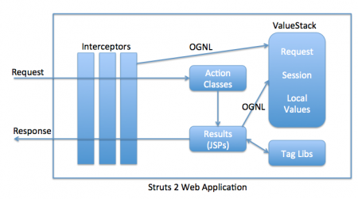

=> Basic Flow of Struts 2
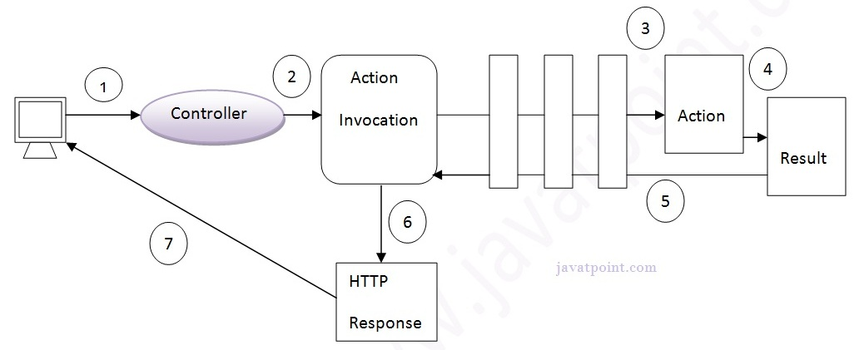
User sends a request for the action
- Controller invokes the ActionInvocation
- ActionInvocation invokes each interceptors and action
- A result is generated
- The result is sent back to the ActionInvocation
- A HttpServletResponse is generated
- Response is sent to the user

=>Standard flow of Struts 2(Struts 2 Architecture)
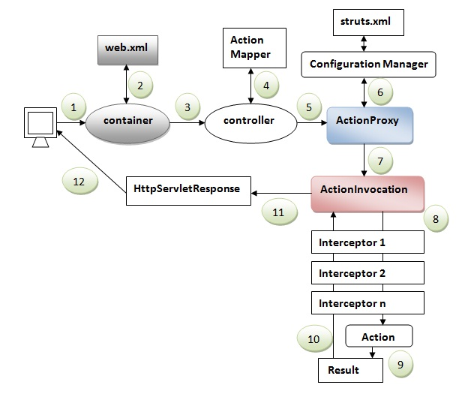
-> User Send a request for action.
-> Container maps the request in the web.xml file and get the calss name of controller.
->Container invokes the controller(StrutsPrepareAndExecuteFilter or FilterDispatcher).
->Since struts2.1, it is StrutsPrepareAndExecuteFilter. Before 2.1 It was FilterDispatcher.
->Controller get the information for the action from ActionMapper.
-> Controller invokes the ActionProxy.
-> ActionProxy gets the information of action and interceptor stacks from the configuration manager which gets the information from the struts.xml file.
->ActionProxy forwards the request to the ActionInvocation.
->ActionInvocation invokes each interceptor and action.
-> A result is generated
-> The result is sent back to the ActionInvocation.
-> A HeetServletResponce is generated.
-> Response is sent to the user.
=>Interceptors:
-> interceptors are conceptually the same as servlet filters or the JDKs Proxy class, Interceptors allow for cross-cutting functionality to be be implemented seperately from the action as well as the framework.
-> You can achieve following using interceptors
a. Providing processing logic before the action is called.
b. Providing postprocessing logic after action is called.
c. Catching exceptions so that alternate processing can be performed.
->Many of the features provided in the struts2 framewor are implemented using interceptors, like exception handling, file uploading, lifecycle call backs, and validations etc.
->

SN | Interceptor & Description
1 | Alias: Allows parameters to have different name aliases across requests.
2 | Checkbox: Assists in managing check boxes by adding a parameter value of false for check boxes that are not checked.
3 | ConversionError: Places error information from converting strings to parameter types into the action's field errors.
4 | CreateSession: Automatically creates an HTTP session if one does not already exist.
5 | Debugging: Provides several different debugging screens to the developer.
6 | ExecAndWait: Sends the user to an intermediary waiting page while the action executes in the background.
7 | Exception: Maps exceptions that are thrown from an action to a result, allowing automatic exception handling via redirection.
8 | FileUpload: Facilitates easy file uploading.
9 | I18n: Keeps track of the selected locale during a user's session.
10 | Logger: Provides simple logging by outputting the name of the action being executed.
11 | Params: Sets the request parameters on the action.
12 | Prepare: This is typically used to do pre-processing work, such as setup database connections.
13 | Profile: Allows simple profiling information to be logged for actions.
14 | Scope: Stores and retrieves the action's state in the session or application scope.
15 | ServletConfig: Provides the action with access to various servlet-based information.
16 | Timer:Provides simple profiling information in the form of how long the action takes to execute.
17 | Token: Checks the action for a valid token to prevent duplicate formsubmission.
18 | Validation: Provides validation support for actions

=>ActionProxy:
-> The ActionProxy obtains the Action class and calls the appropriate methods.
-> By default, Actions are obtained through local instantiation, but an Action could also be obtained remptely if an alternative ActionProxy were provided.
->An alternative ActionProxy can be configured through ActionProxyfactory. Typically, an ActionProxy will utilize the ActionInvocation to encapsulate the execution of a particularr equest.
->Essentially, ActionProxy encapsulates how an Action can be obtained. ActionInvocation encapsulates how the Action is executed when a request is invoked.
ActionProxyFactory.getFactory(new MyActionProxyFactory() {
....
public ActionProxy createActionProxy(Configuration config,
String namespace, String actionName, Map extraContext)
throws Exception {
createActionProxy(config, namespace, actionName, extraContext, true);
}
public ActionProxy createActionProxy(Configuration config,
String namespace, String actionName, Map extraContext,
boolean executeResult, boolean cleanupContext)
throws Exception {
....
}
....
})

=>ActionInvocation:
-> ActionInvocation represents the execution of state of an action. It holds the action and interceptors.
-> ActionInvocation interface deals with the ActionInvocations.
-> It provides many of the methods, some of them is used to get the instance of valuestacks, ActionProxy, ActionContext, Result etc.
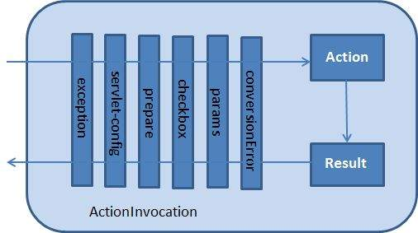

->List of methods in ActionInvocation interface.

No. | Method | Description
1) | public ActionContext getInvocationContext() | returns the ActionContext object associated with the ActionInvocation.
2) | public ActionProxy getProxy() | returns the ActionProxy instance holding this ActionInvocation.
3) | public ValueStack getStack() | returns the instance of ValueStack.
4) | public Action getAction() | returns the instance of Action associated with this ActionInvocation.
5) | public void invoke() | invokes the next resource in processing this ActionInvocation.
6) | public Result getResult() | returns the instance of Result.

